

**Discipline**

**Relational Schema**

***(3 versions)***

**CS5201**

Stage-2

**Sheikh Muhammed Tadeeb (AU19B1014)**

* **Rules to map ER-model to Relational Schema:**

1. **Strong Entity:**

* Create a table for each strong entity and its attribute becomes its field.
* Declare primary key and foreign key (if any).

1. **Weak Entity:**

* Create table for each weak entity set and add its attributes as field
* Create separate tables for all leaf entities (which doesn’t have further ISA) with its attributes as fields and add primary key of upper order entity in them, which will act as foreign key here.

1. **Relations:**
2. For one-one type of participation, add primary key of the 1st table to the second one – it becomes foreign key in the second table.

* Any extra attribute tied to relation becomes its attribute too.

1. For one-many type of participation, add primary key of the table on “one side” to the table present on “many side” – it becomes foreign key in “many side” table.

* Any extra attribute tied to relation becomes its attribute too.

1. For many-many type of participation, create a separate new table for relationship set with composite key as combination of primary keys of two table present in relationship. Also make them Foreign keys here.

* Any extra attribute tied to relation becomes its attribute too.

1. For each multivalued attribute, create a new separate table and add primary key of original table as its attribute along with the other attribute (NOTE: Don’t add these attributes to the main table then and primary key of original table will be foreign key here). They both will combine to become composite key of this table.
2. For composite attribute add the branched attributes directly to the main table, ignore the attribute from which branches are coming out.

**Relational Schema**

**Version-1**

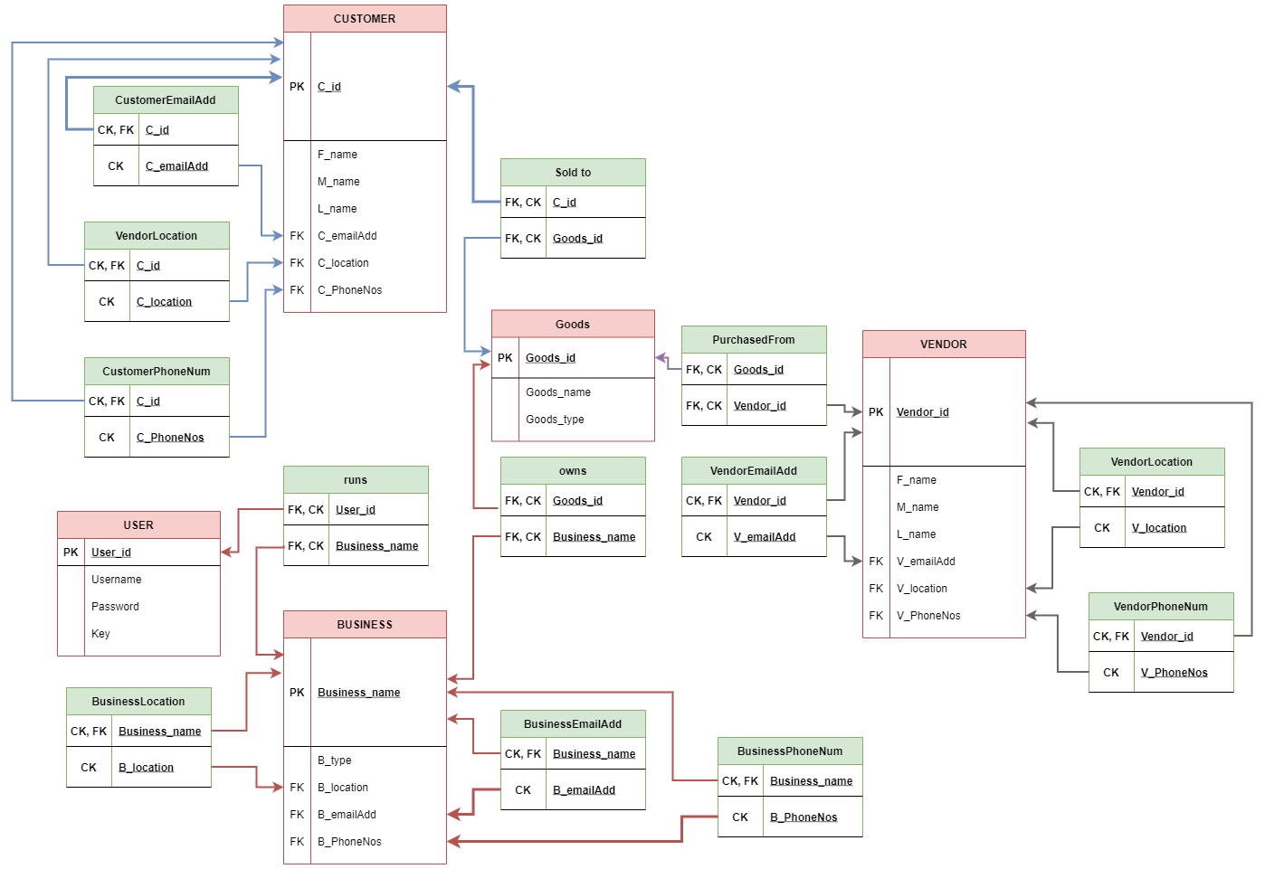

|  |  |
| --- | --- |
| **PK** | **Primary Key** |
| **FK** | **Foreign Key** |
| **CK** | **Composite Key** |
| **FK/CK PK** | **Showing Reference** |

**Relational Schema**

**Version-2**

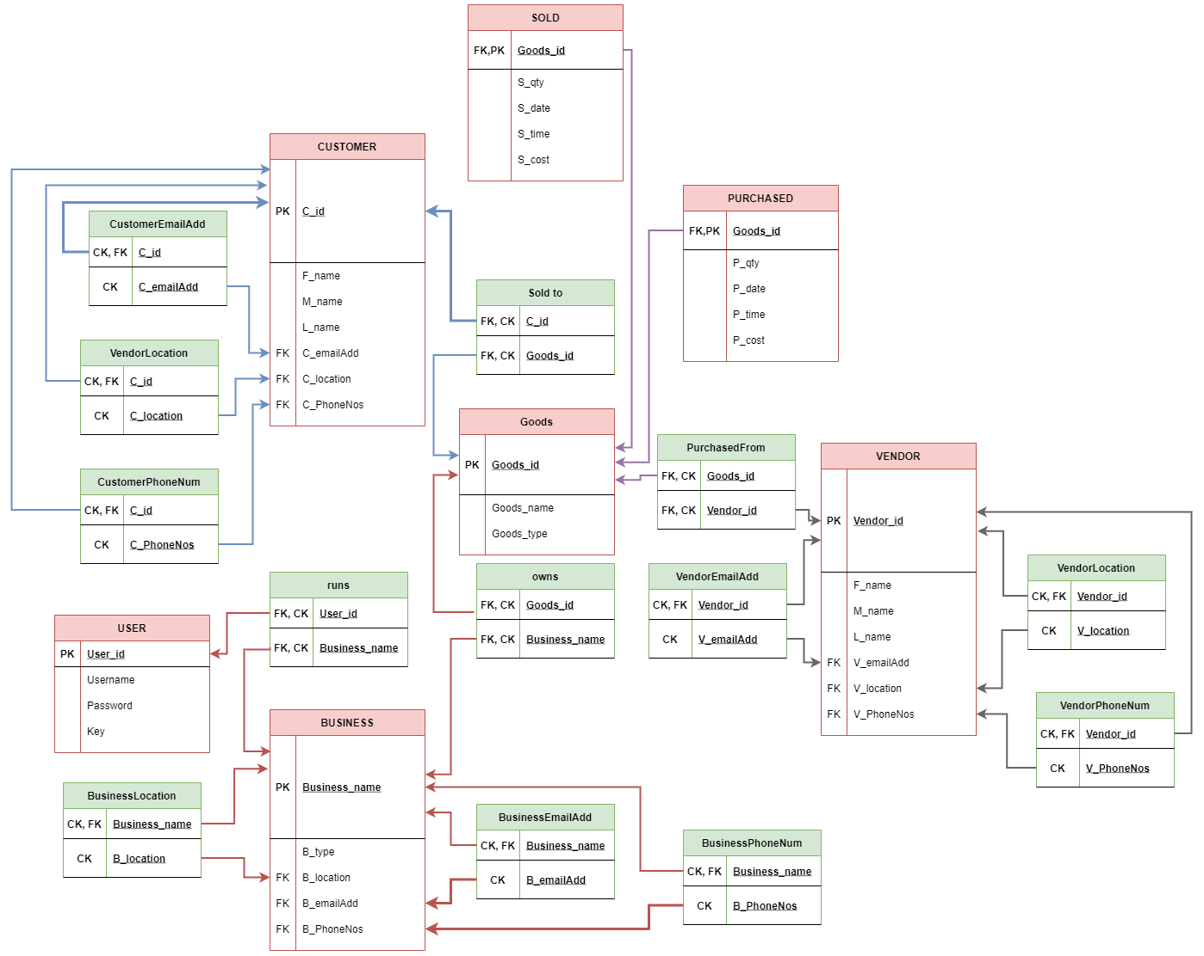

|  |  |
| --- | --- |
| **PK** | **Primary Key** |
| **FK** | **Foreign Key** |
| **CK** | **Composite Key** |
| **FK/CK PK** | **Showing Reference** |

**Relational Schema**

**Version-3**

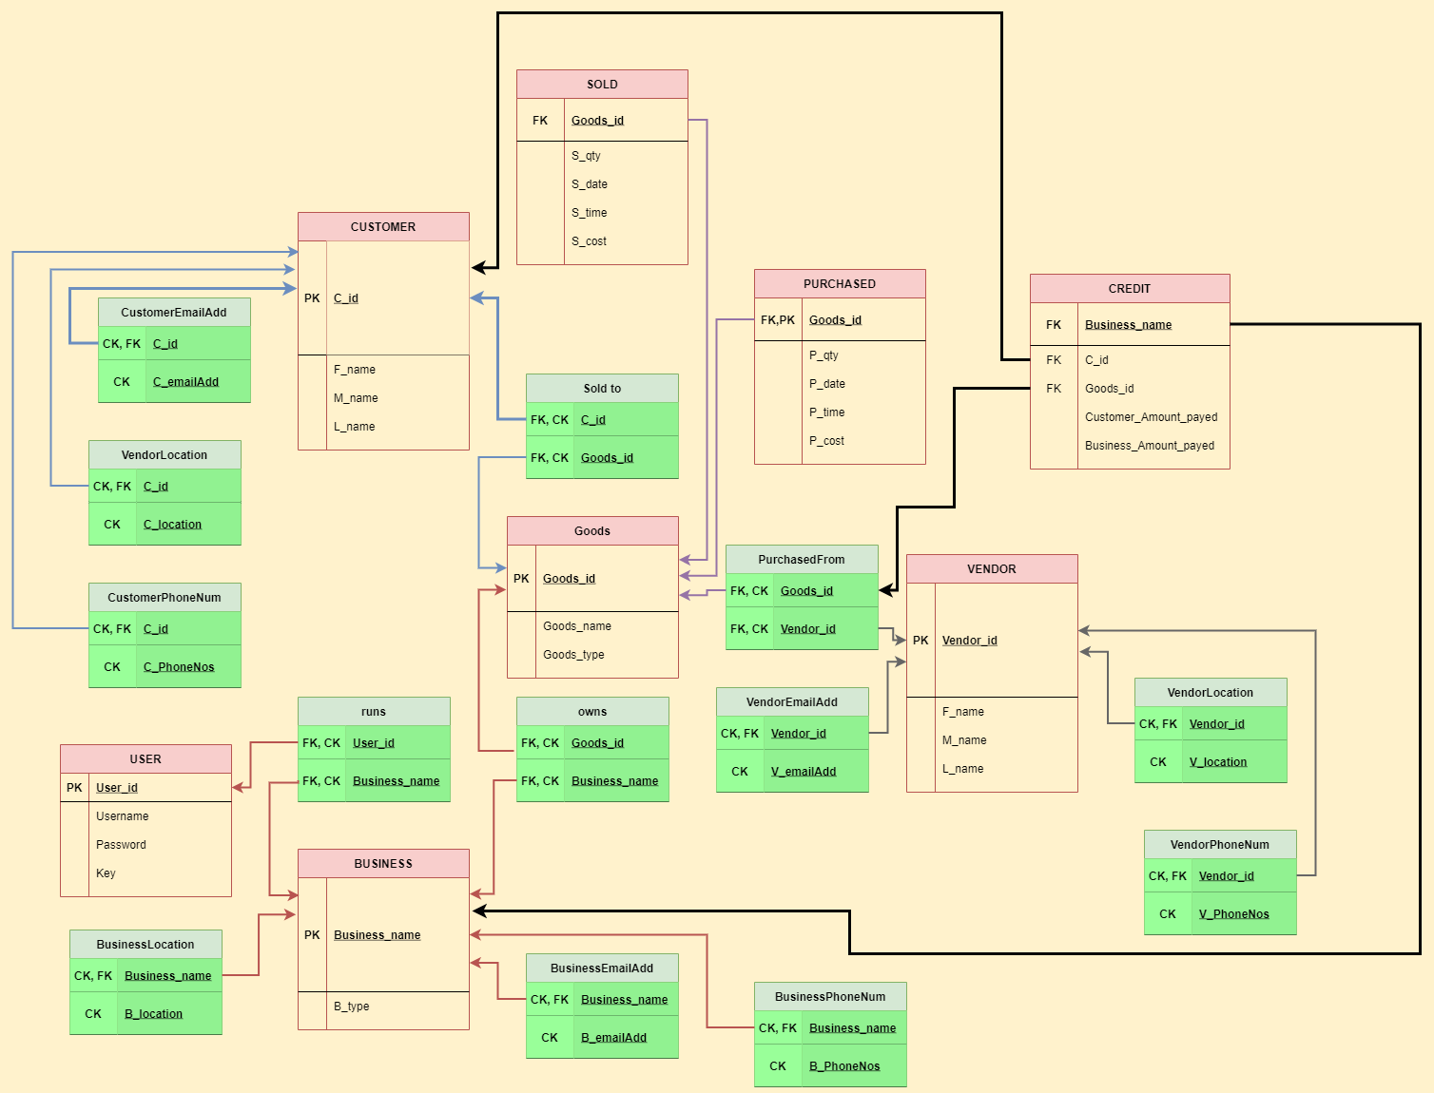

|  |  |
| --- | --- |
| **PK** | **Primary Key** |
| **FK** | **Foreign Key** |
| **CK** | **Composite Key** |
| **FK/CK PK** | **Showing Reference** |